STANTON LACY PARISH COUNCIL
FINANCIAL ACCOUNTS
FOR THE YEAR ENDED 31ST MARCH 2019

The Local Audit and Accountability Act of 2014 and the Accounts and Audit Regulations 2015 require all authorities to prepare a statement of accounts for each financial year in accordance with proper practises.

Where an authority’s gross income and expenditure accounts is not more than £200,000 for that year, or for either of the two immediately preceding financial years, the statement may take the form of a summary receipts and payments, as here.

Financial Accounts approved by the Parish Council at its meeting on the 16th May 2019.

These Accounts have been audited by the Parish Council’s Internal Auditor.

SUMMARY RECEIPTS AND PAYMENTS ACCOUNT
FOR THE YEAR ENDED 31ST MARCH 2019

INCOME | 2018/2019
Carried Forward from 2017/18 | 5,435.92
Precept | 3,415.00
VAT reclaimed | 416.46
Environmental Maintenance Grant | 500.00
Interest | .66
TOTAL INCOME | 9,768.04 |  | 9,768.04

EXPENDITURE | 2018/2019
Audit | 25.00
Election Expenses | 100.00
Clerks Salary | 1,280.82
Administration | 98.25
Meeting Room | 240
Insurance | 167.44
Citizens Advice Bureau Donation | 60.00
Shropshire Association Local Council Subscription | 177.18
IT Equipment and Software | 59.99
Travel and Mileage Costs | 79.65
General Data Protection Information Commissioners Fee | 35.00
Website Costs | 250.63
Environmental Maintenance (Lengthsman) | 680.50
Neighbourhood Fund (Village Hall Internet Connection) | 117.00
TOTAL EXPENDITURE | (3,371.46) |  | (3,371.46)

RECONCILIATION |  | 6,396.58
Balance at Lloyds on 31/3/19 | 6396.58
Less Uncleared Cheques | None
Balance Carried Forward 6,396.58

ASSETS

BANK ACCOUNTS

The Parish Council opened a savings account to hold the reserve and holding for projects. As of the 31st March 2019:
Lloyds Bank Current Account: £2816.86 which includes £944. 97 retained for the Lengthsman contract
Lloyds Bank Savings Account:
Transparency Fund | 440.18
IT Fund | 540.02
Parish Plan | 77.6
Neighbourhood / CIL | 491.43
First Aid in the Community | 950
Defibrillators | 307.83
Reserves | £772.00
Interest | 0.66
 | 3579.72

There is no Petty Cash Account.
ITEMS OVER £100:
1/9/18 Village Hall Internet Connection SWS Broadband £117.00

Prepared by: Heather Coonick, Clerk/Responsible Finance Officer
Date: 31/3/19
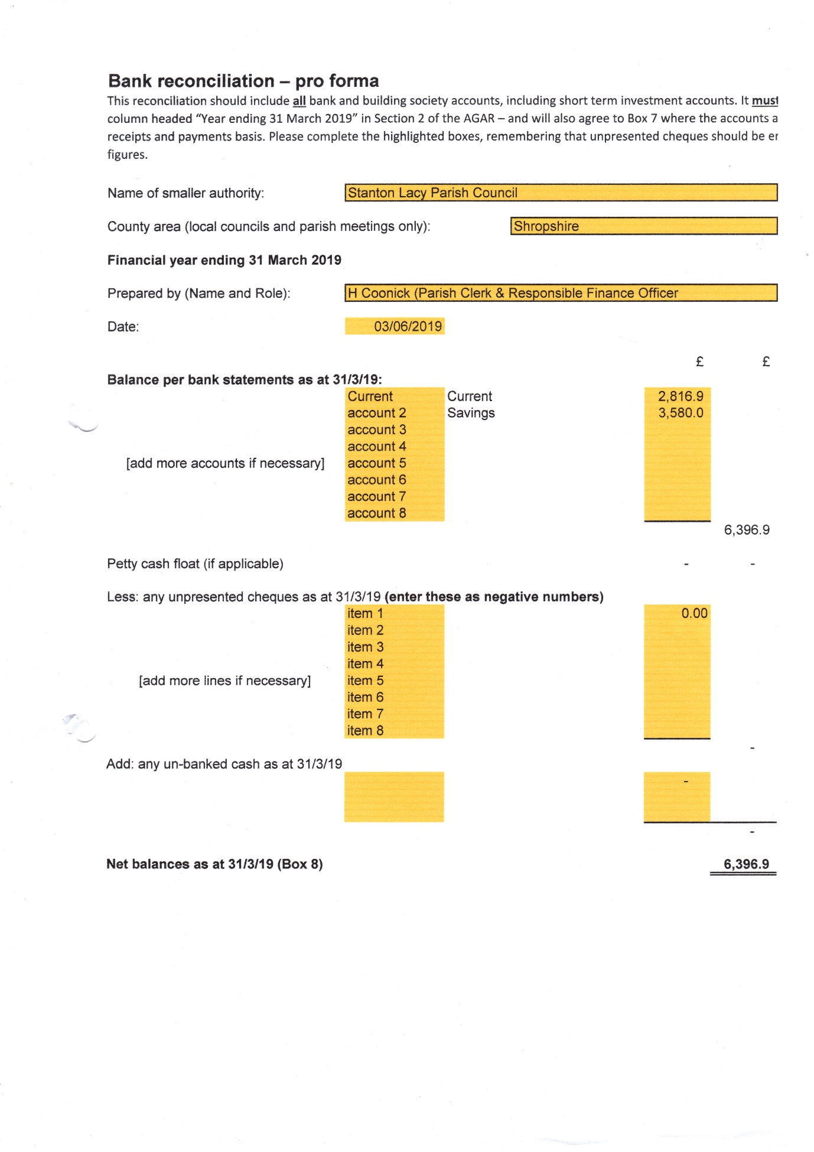

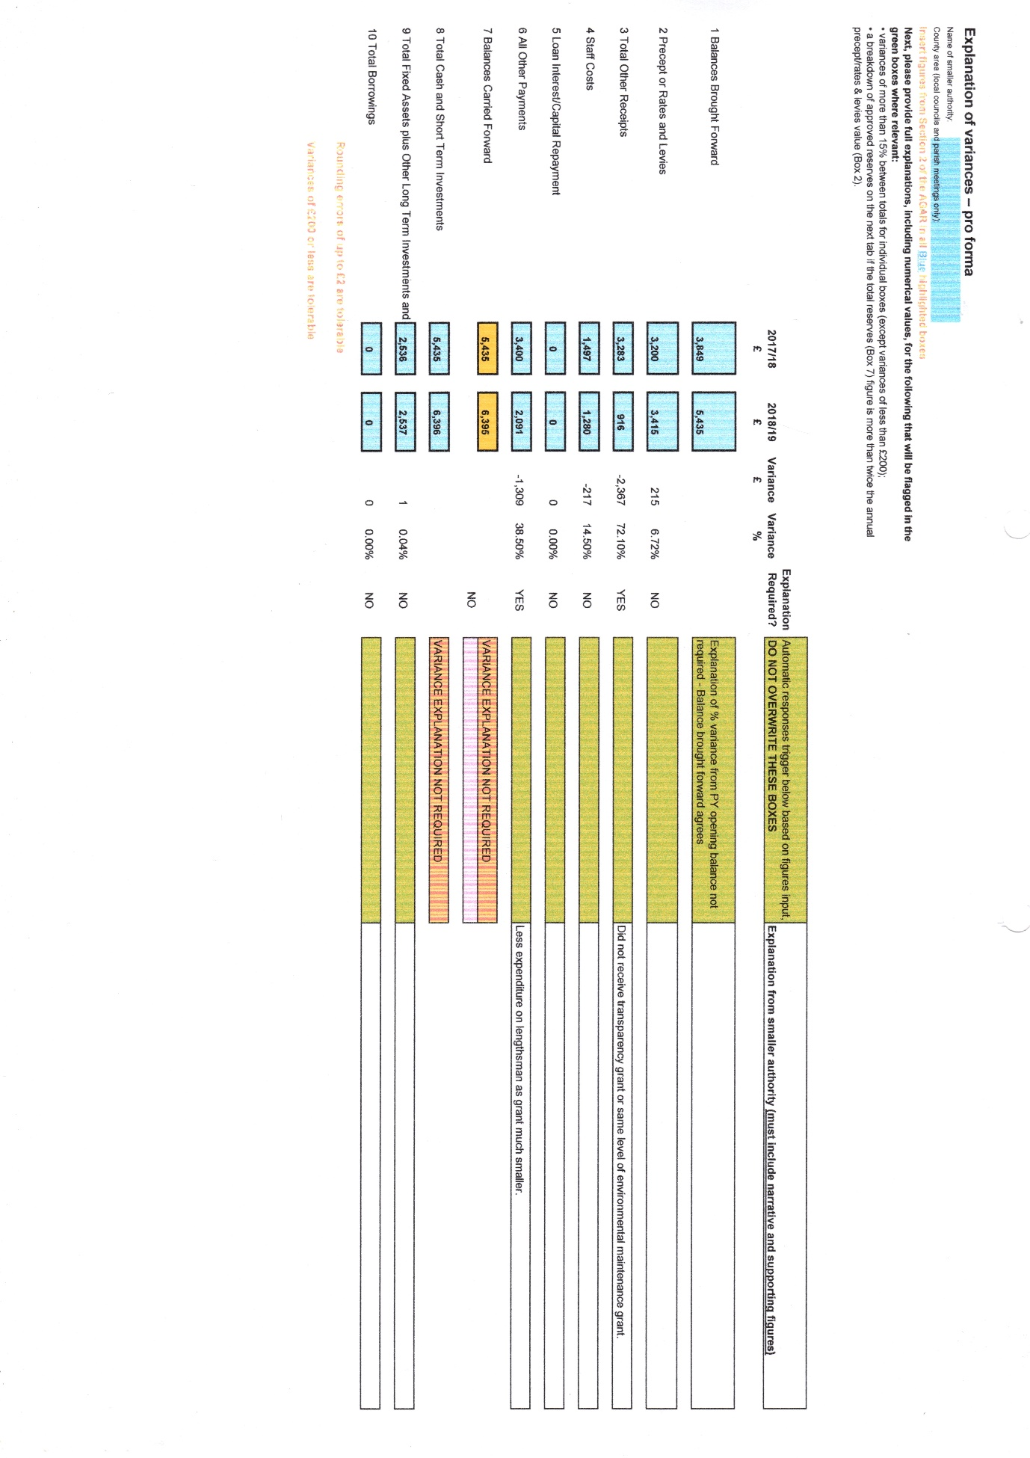

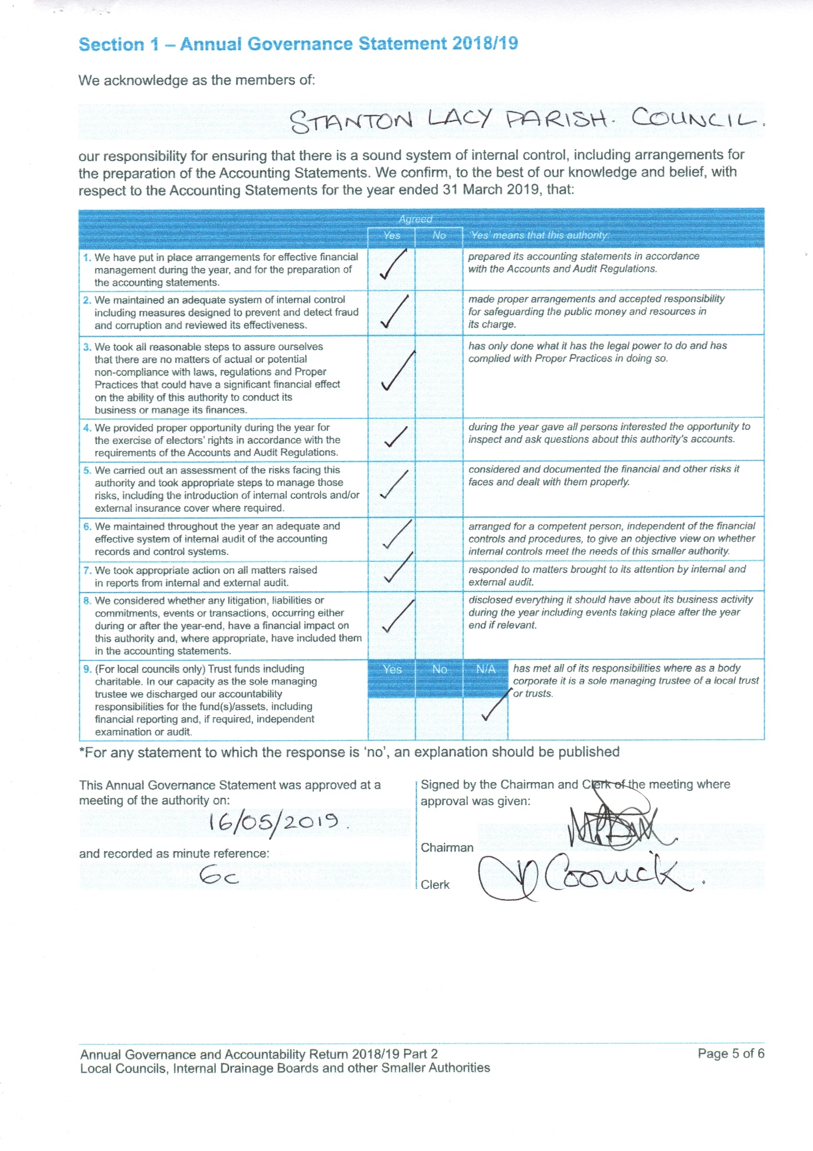

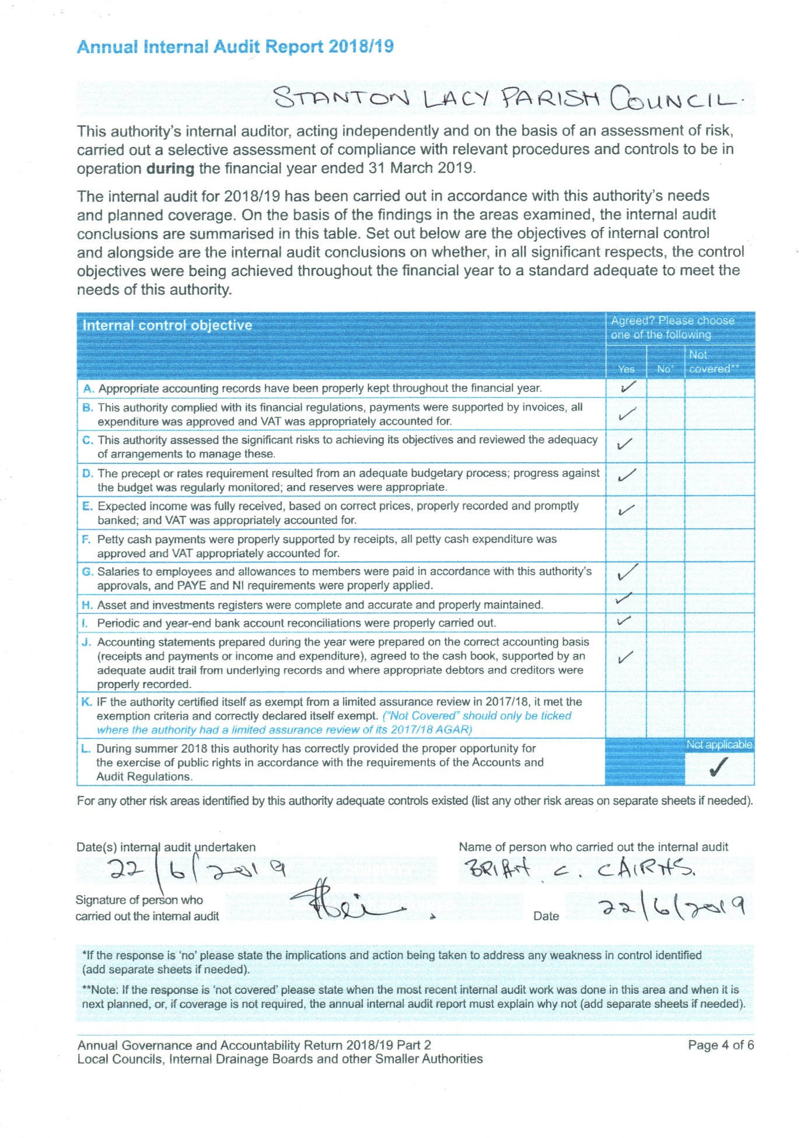

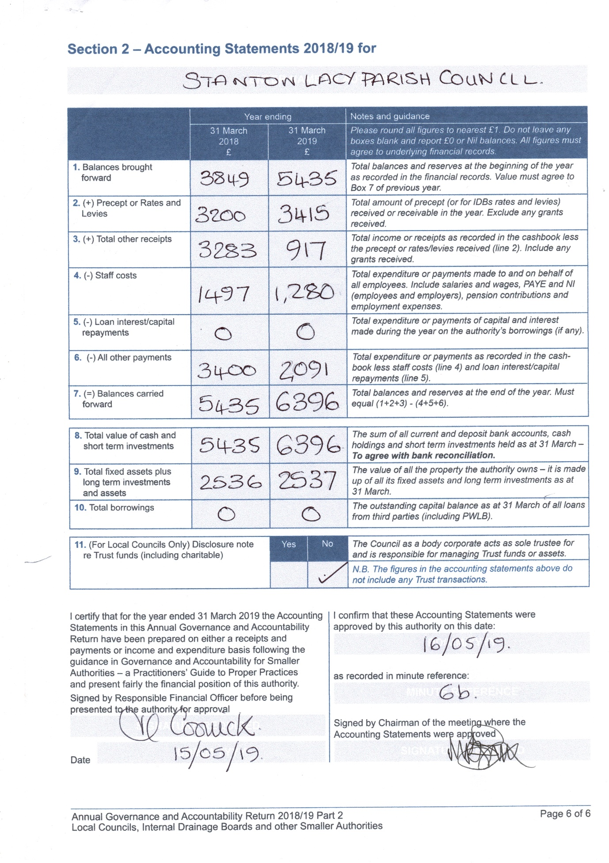

Stanton Lacy Parish Council

NOTICE OF PUBLIC RIGHTS AND PUBLICATION OF ANNUAL GOVERNANCE & ACCOUNTABILITY RETURN (EXEMPT AUTHORITY)
ACCOUNTS FOR THE YEAR ENDED 31 MARCH 2019

Local Audit and Accountability Act 2014 Sections 25, 26 and 27
The Accounts and Audit Regulations 2015 (SI 2015/234)
NOTICE
1. Date of announcement: 29th June 2019 (a)
2. Each year the smaller authority prepares an Annual Governance and Accountability Return (AGAR). The AGAR has been published with this notice. It will not be reviewed by the appointed auditor, since the smaller authority has certified itself as exempt from the appointed auditor’s review.
Any person interested has the right to inspect and make copies of the AGAR, the accounting records for the financial year to which it relates and all books, deeds, contracts, bills, vouchers, receipts and other documents relating to those records must be made available for inspection by any person interested. For the year ended 31 March 2019, these documents will be available on reasonable notice by application to:

(b) Heather Coonick (Clerk and RFO), Hopton Gate Cottage, Haytons Bent, Ludlow. SY8 2BE. 07817607355. stantonlacypc@gmail.com

commencing on (c) Monday 1st July 2019

and ending on (d) Friday 10th August

3. Local government electors and their representatives also have:

- The opportunity to question the appointed auditor about the accounting records; and
- The right to make an objection which concerns a matter in respect of which the appointed auditor could either make a public interest report or apply to the court for a declaration that an item of account is unlawful. Written notice of an objection must first be given to the auditor and a copy sent to the smaller authority.

The appointed auditor can be contacted at the address in paragraph 4 below for this purpose between the above dates only.

4. The smaller authority’s AGAR is only subject to review by the appointed auditor if questions or objections raised under the Local Audit and Accountability Act 2014 lead to the involvement of the auditor. The appointed auditor is:

PKF Littlejohn LLP (Ref: SBA Team)
1 Westferry Circus
Canary Wharf
London E14 4HD
(sba@pkf-littlejohn.com)

5. This announcement is made by (e) Heather Coonick (Clerk and RFO)

